**Understanding Customer Behavior through Transactional Data Analysis**

**Introduction:**

Understanding customer behavior is crucial for businesses to tailor their strategies effectively. With the advent of big data analytics, businesses can now delve deep into transactional data to gain insights into customer preferences, purchasing patterns, and overall behavior. This project aims to perform Exploratory Data Analysis (EDA) on transactional data to derive valuable insights into customer behavior for selected stores.

**Objectives:**

1. Explore and understand the provided dataset, including the structure, variables, and missing/incomplete data.

2. Clean and preprocess the data to ensure its quality and reliability for analysis.

3. Analyze customer purchasing patterns, such as frequency of purchases, average transaction value, and popular product categories.

4. Identify customer segments based on demographic factors or purchasing behavior.

5. Investigate the correlation between customer behavior and external factors such as promotional activities or seasonal trends.

6. Develop predictive models to forecast customer spending or predict total sales value for validation data.

7. Derive actionable insights to help businesses optimize marketing strategies, improve customer satisfaction, and drive revenue growth.

**Data Description:**

**Hackathon_Ideal_Data:** Contains brand level data for 10 stores for the last 3 months.

**Hackathon_Working_Data:**Includes data for selected stores with missing and/or incomplete information.

**Hackathon_Mapping_File:** Provides column names and descriptions for better understanding of the dataset.

**Hackathon_Validation_Data:** Data stores and product groups for which total value prediction is required.

**Sample Submission:** Represents the format for uploading output, including columns and values required.

**Methodology:**

* **Data Preprocessing:** Clean the dataset, handle missing values, and transform variables if necessary.
* **Exploratory Data Analysis (EDA):** Explore the dataset through summary statistics, visualizations, and correlation analysis to understand customer behavior.
* **Customer Segmentation:** Utilize clustering algorithms to identify distinct customer segments based on their purchasing behavior.
* **Predictive Modeling:** Develop predictive models using regression or time series analysis to forecast customer spending or predict total sales value for validation data.
* **Interpretation and Insights:** Interpret the results of analysis and modeling to derive actionable insights for business stakeholders.

*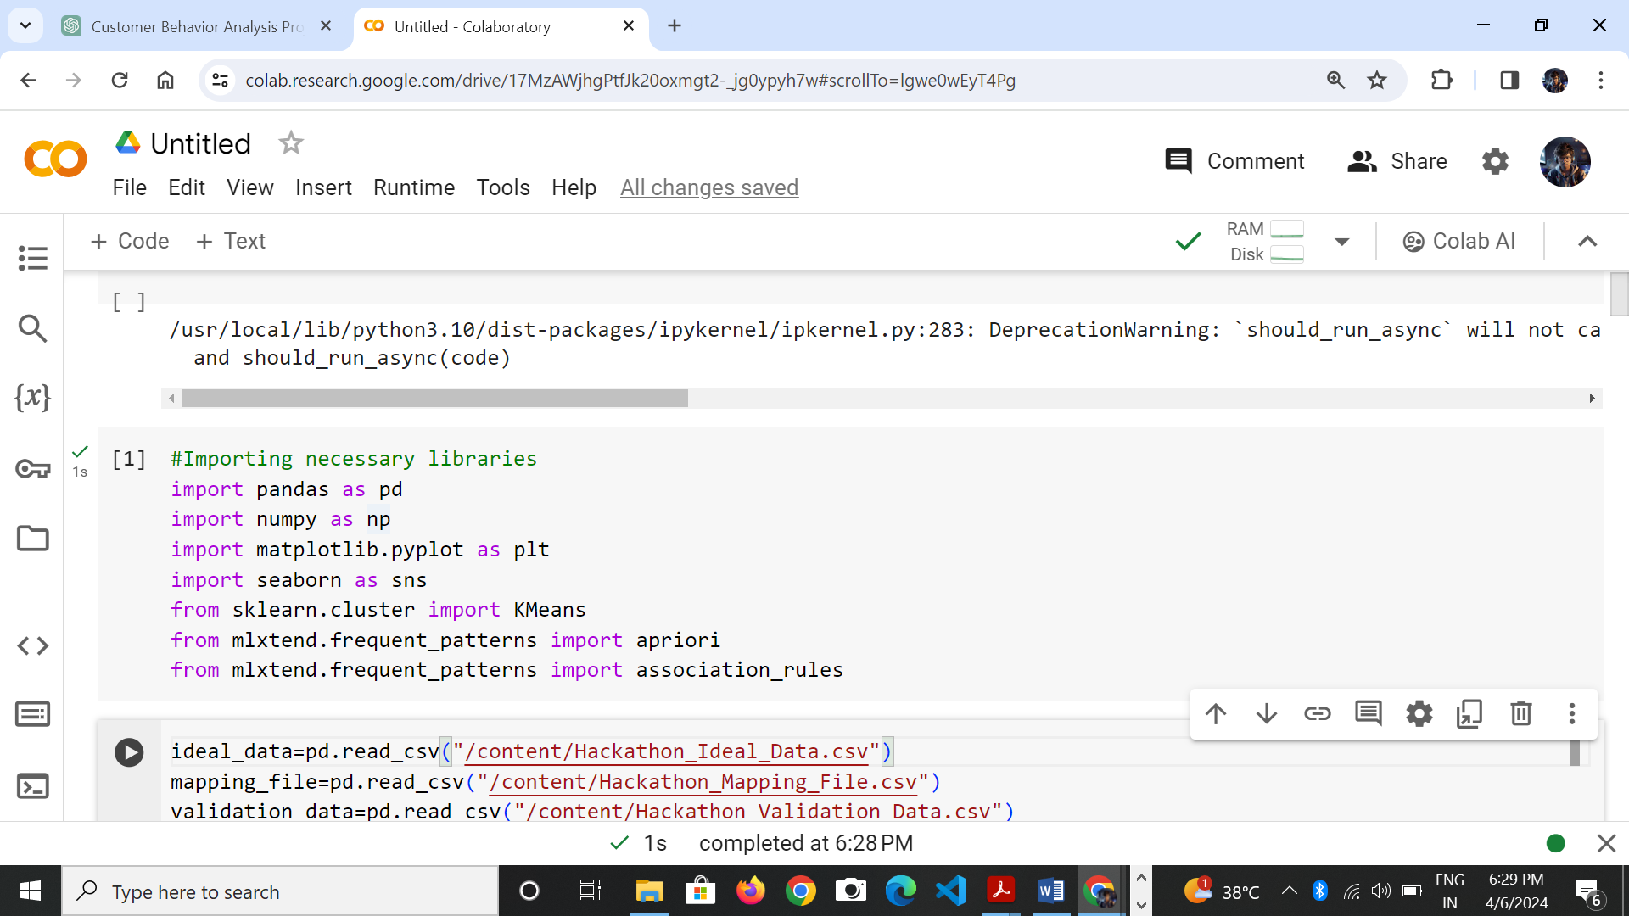***Importing necessary libraries:**

**Importing datasets:**

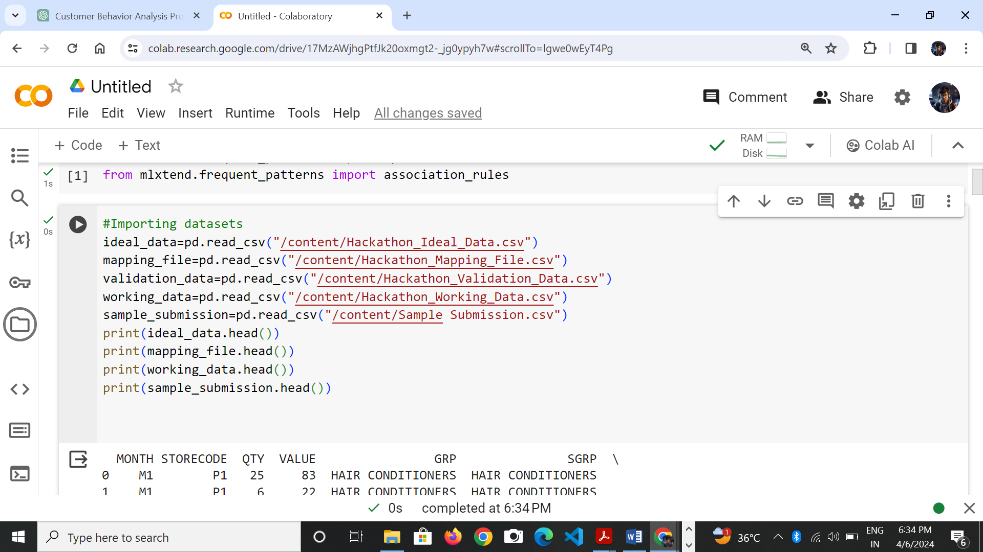

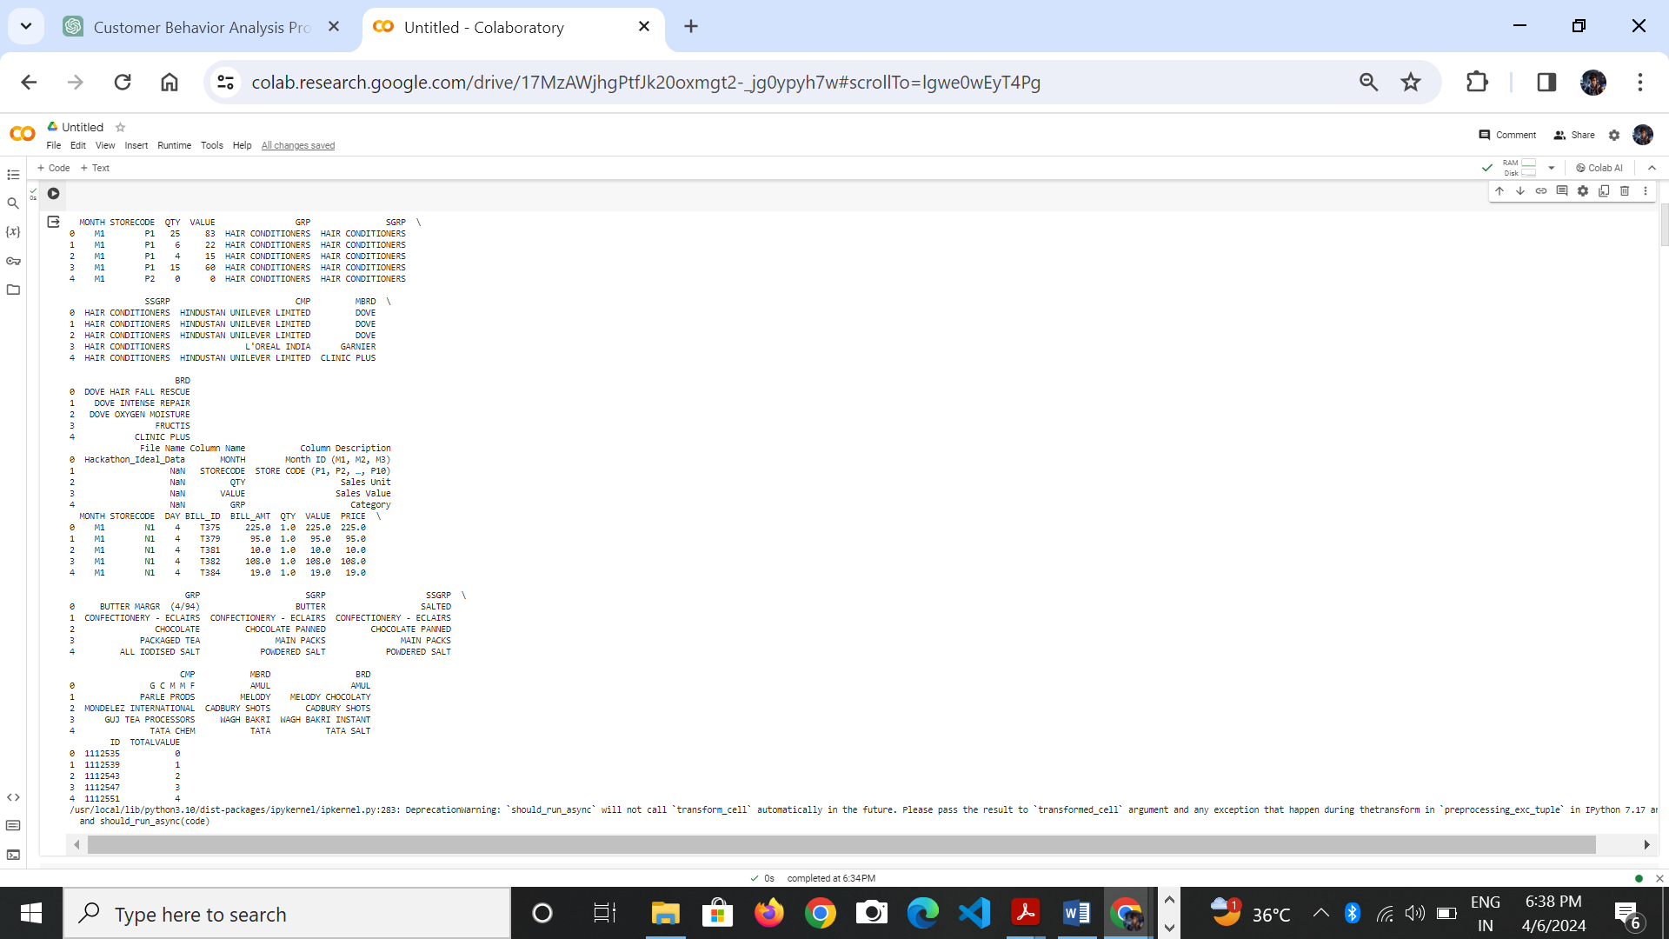**Display the dataset:**

**Handling Missing Values:**

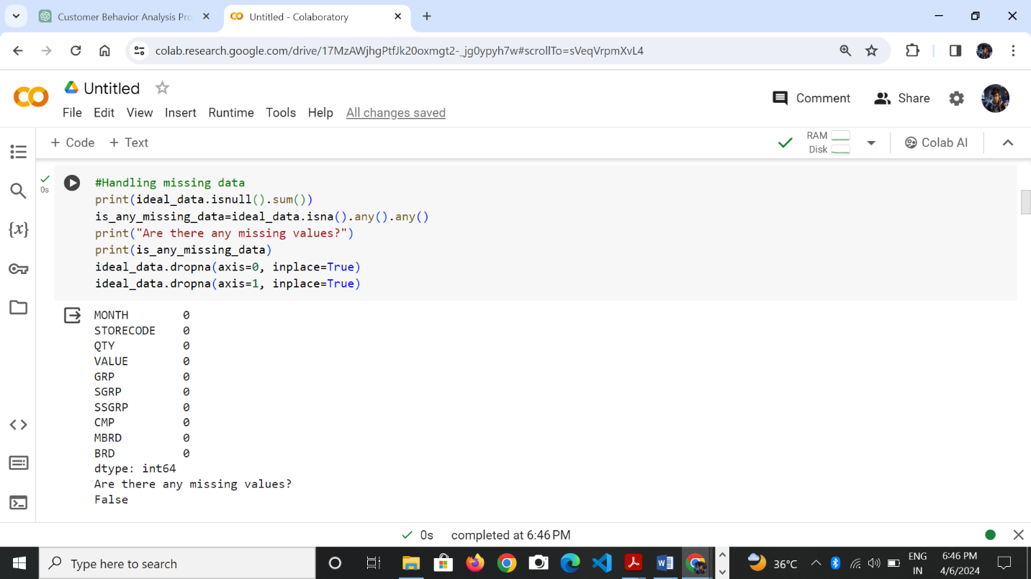To identify missing values and removing the missing values:

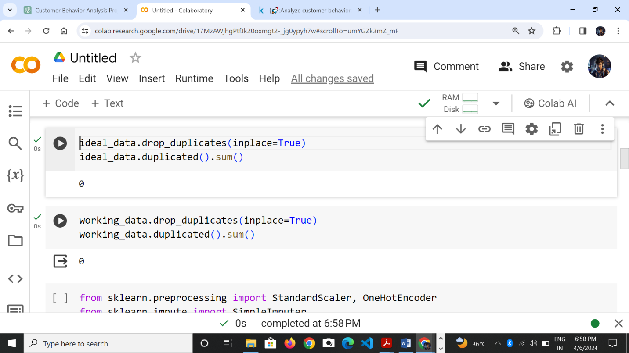Removing duplicates values:

**Data Processing And Feature Engineering**

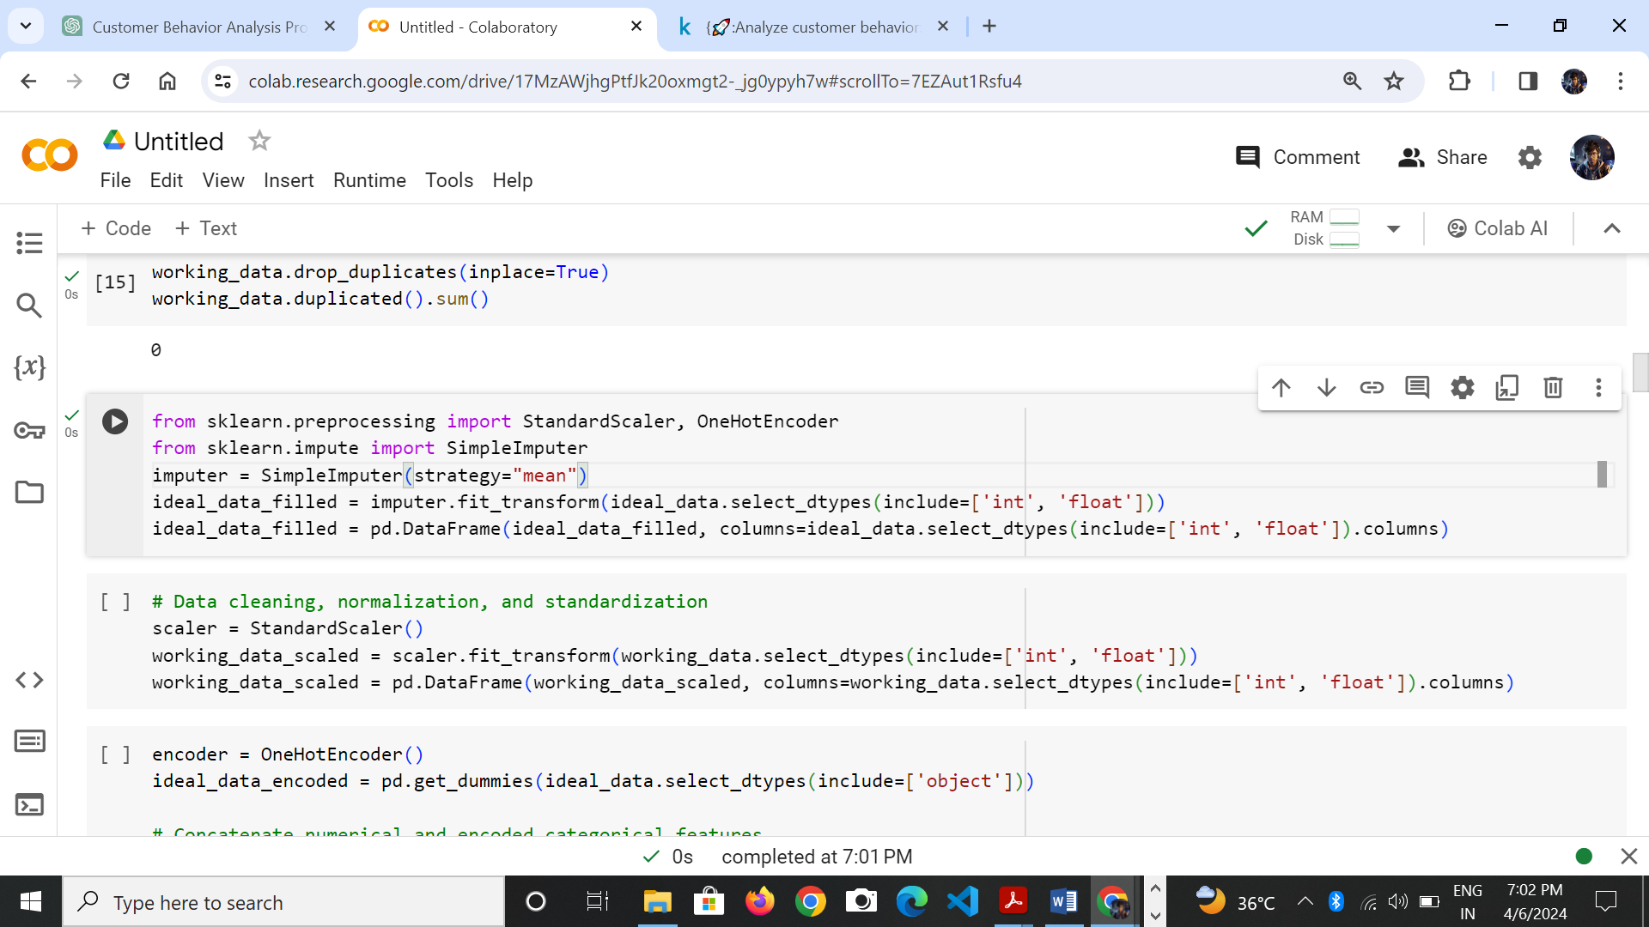

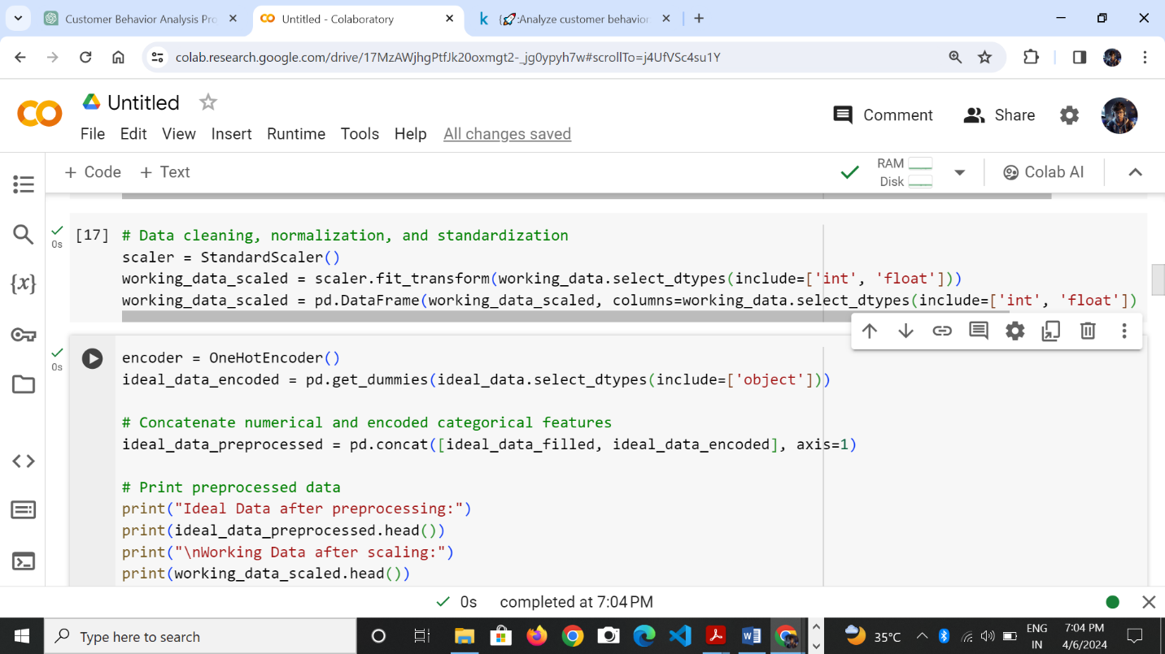Data cleaning,normalization and standardization:

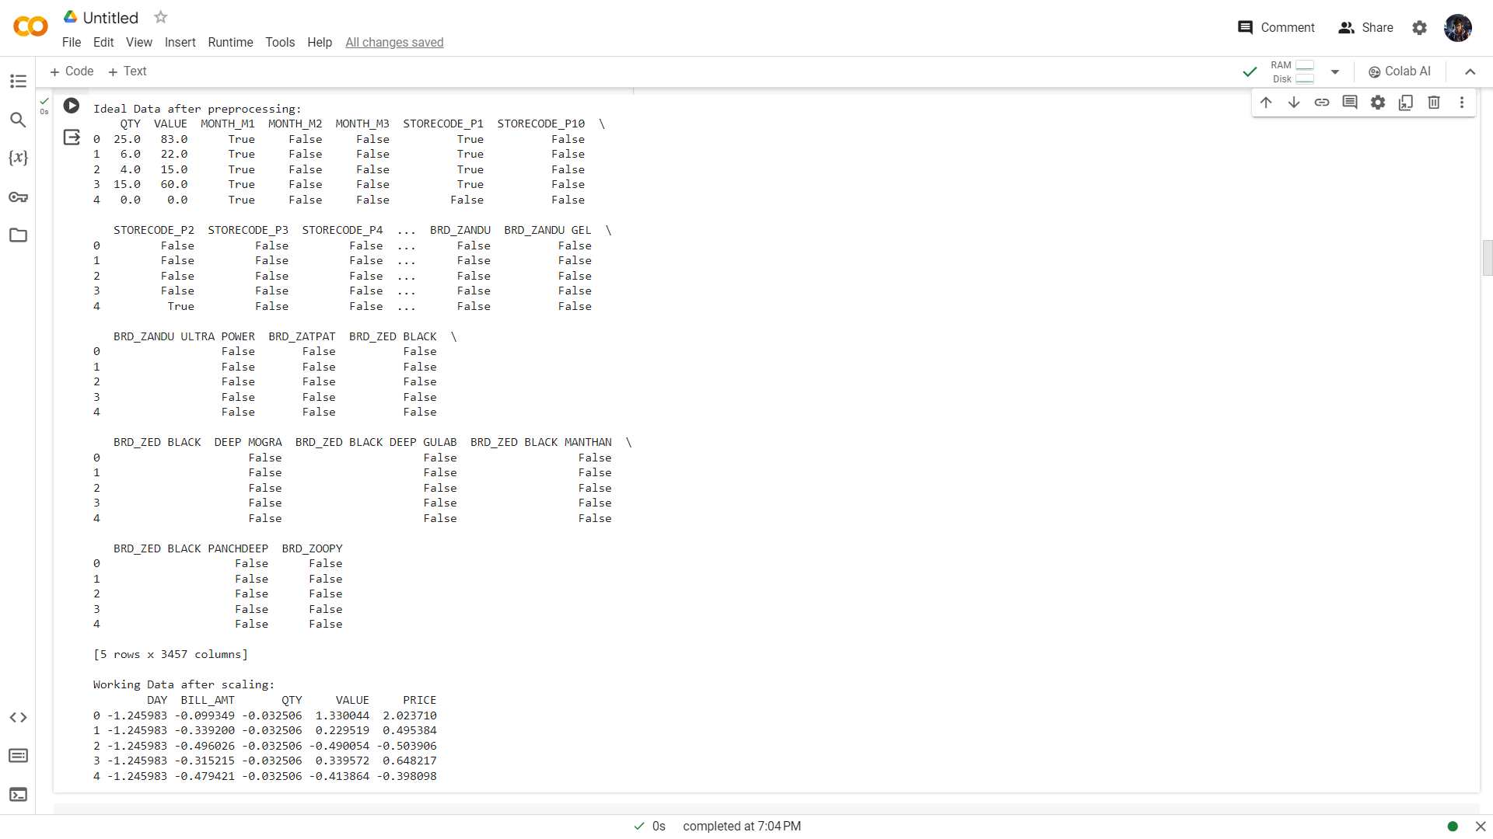Ideal Data after preprocessing:

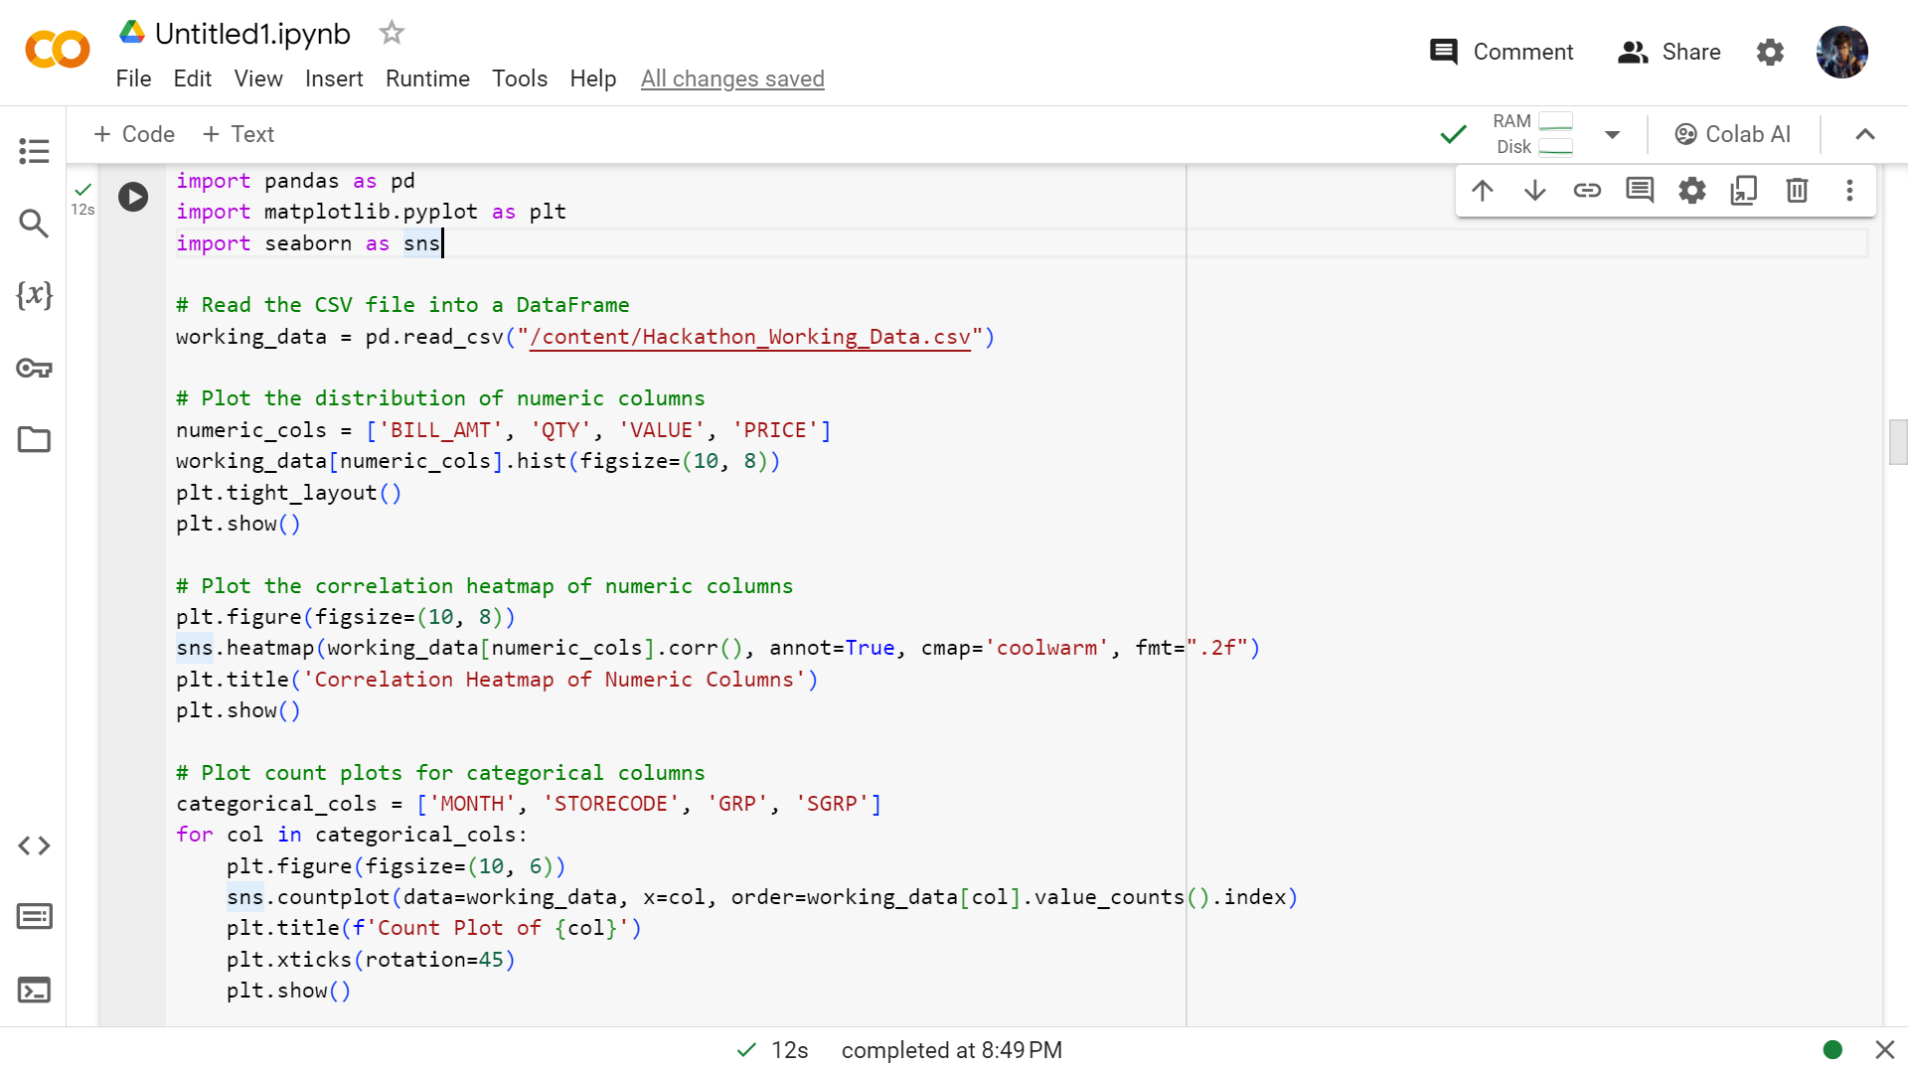  
**Exploratory Data Analysis (EDA)**

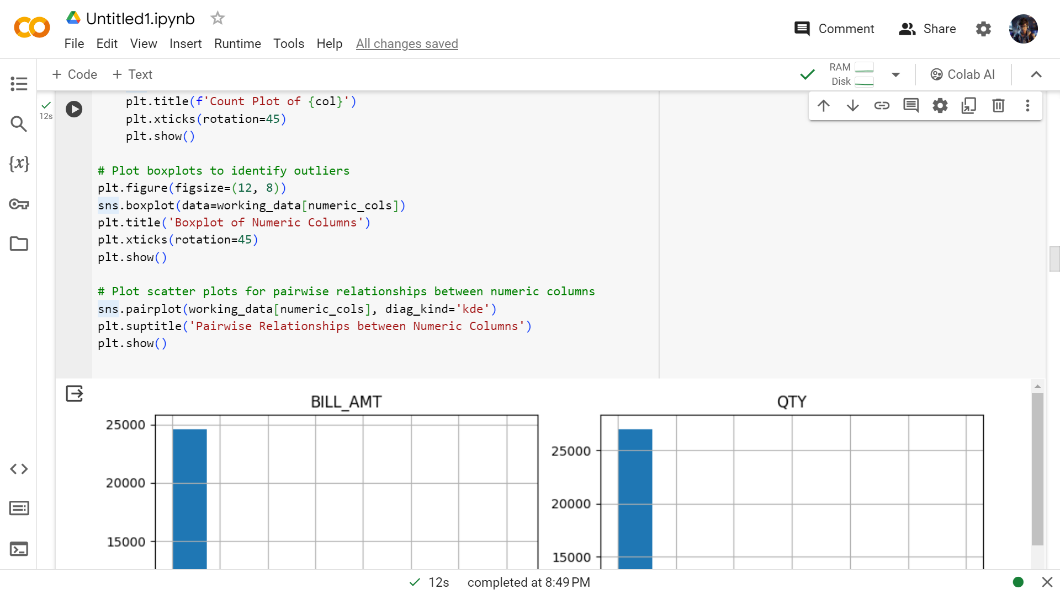

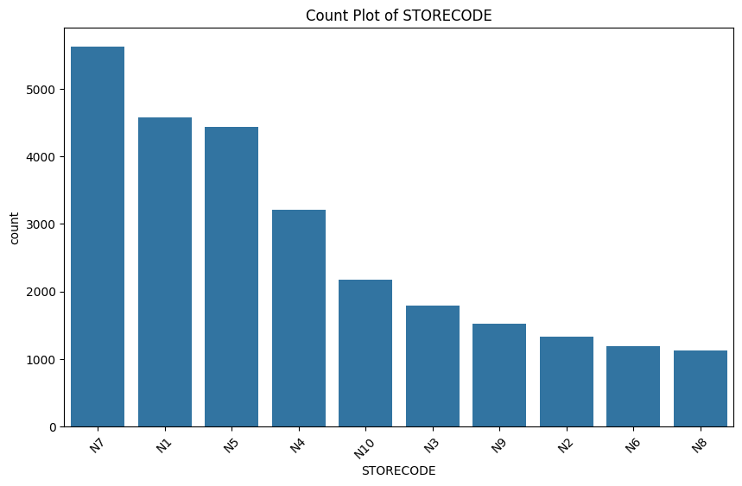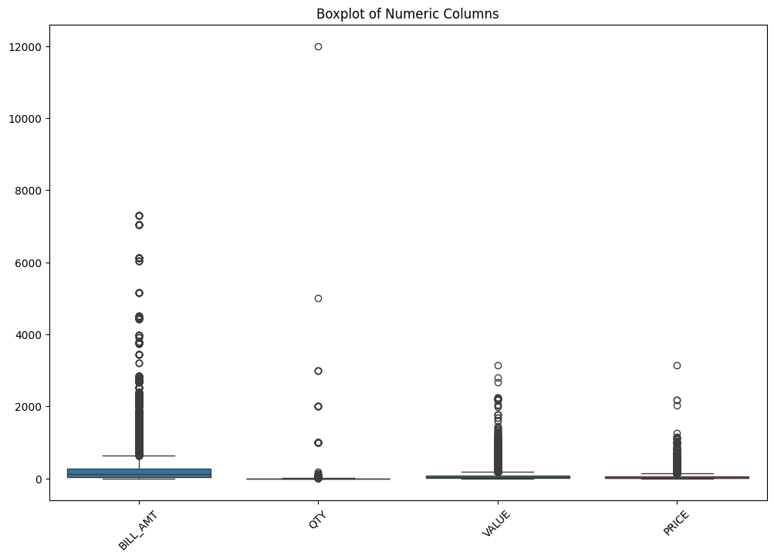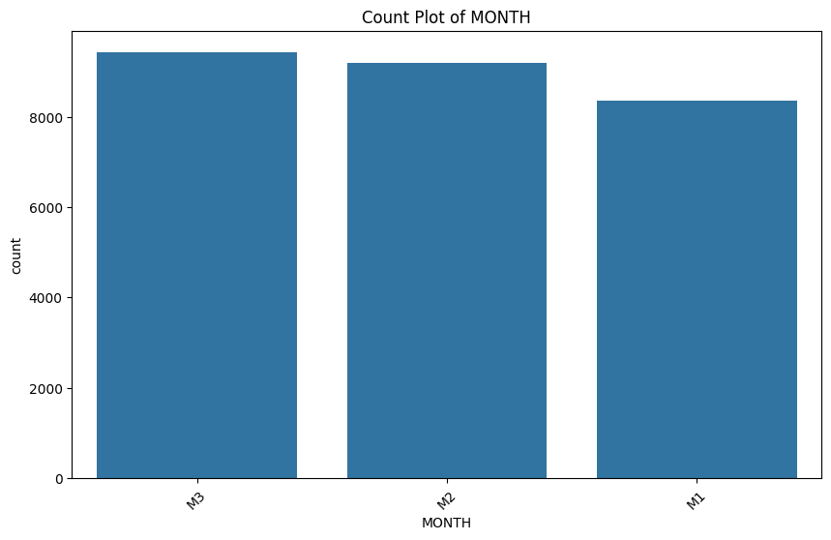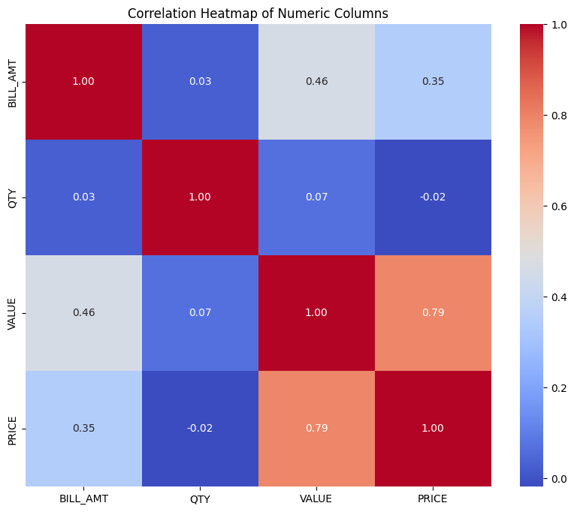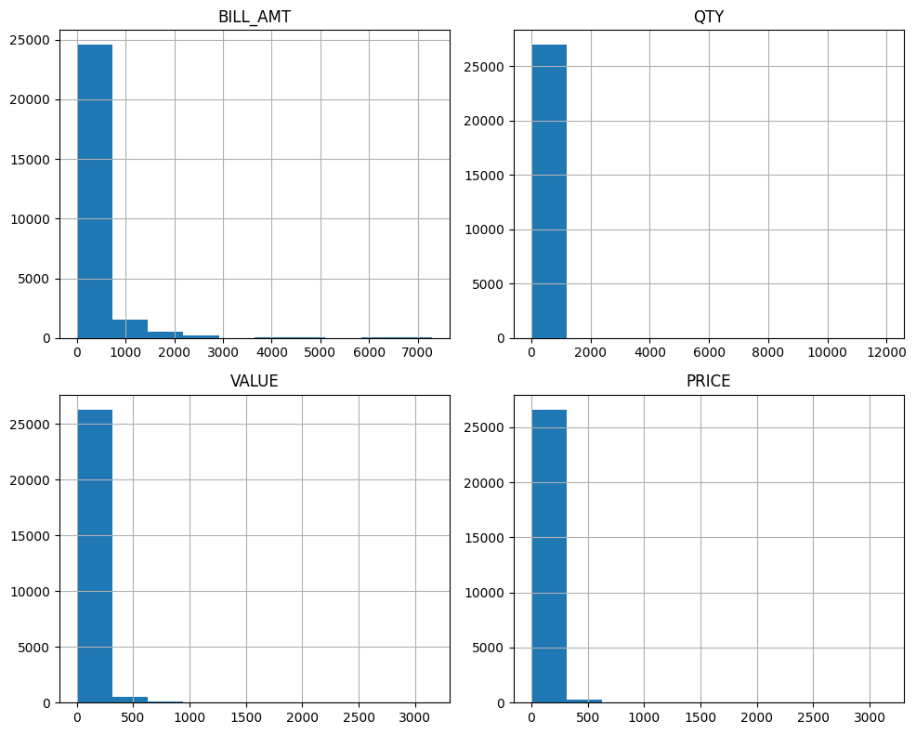

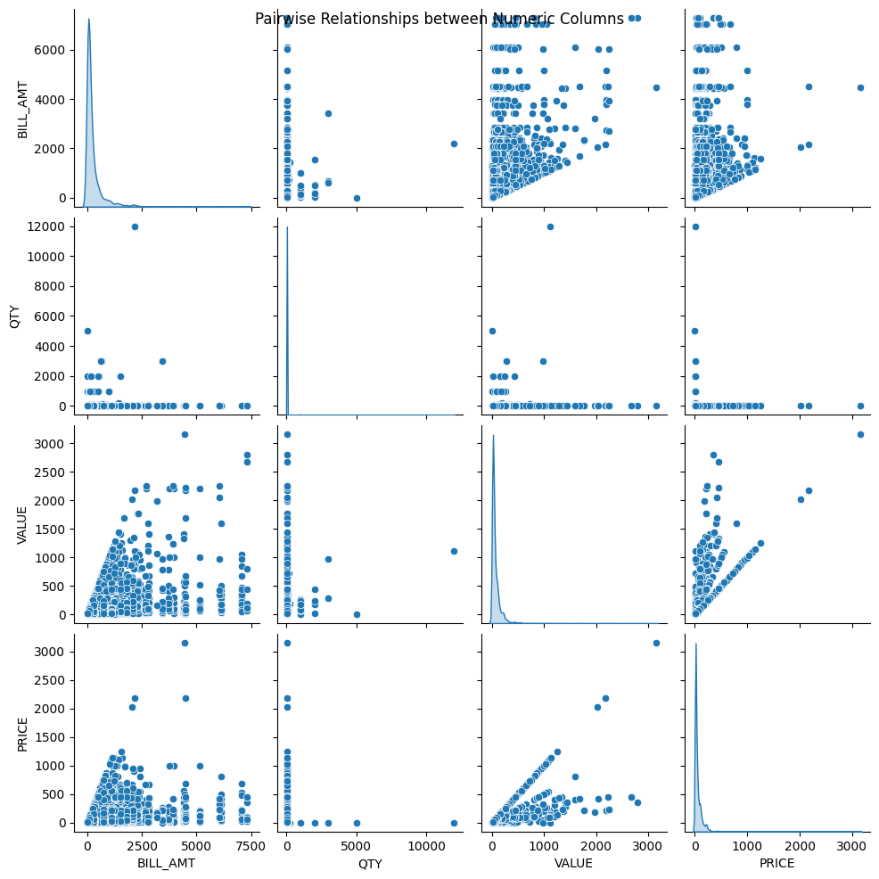**Customer Segmentation with K-means Clustering**

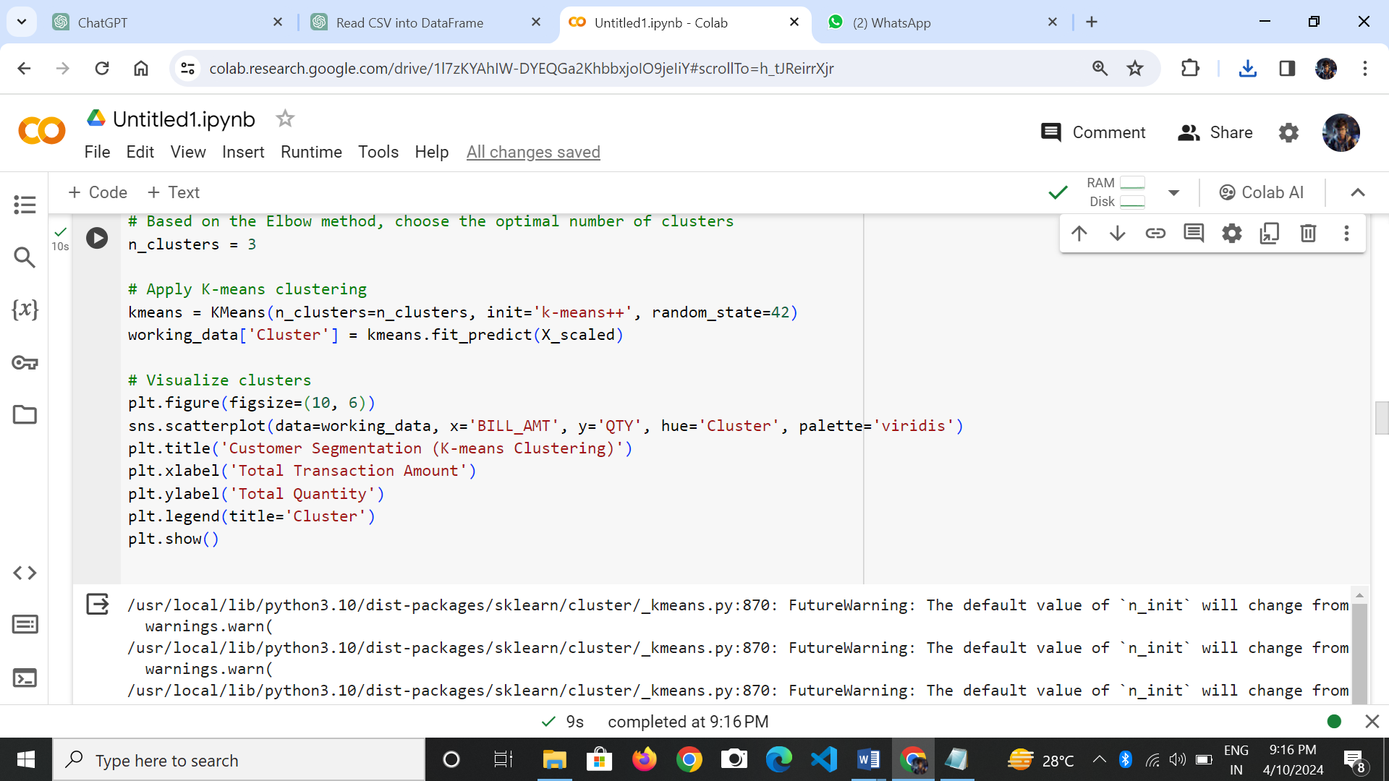

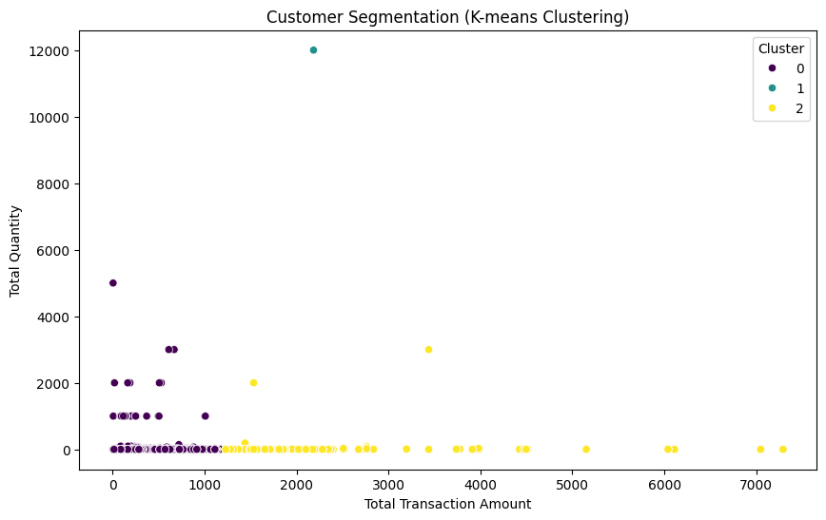**OUTPUT:**

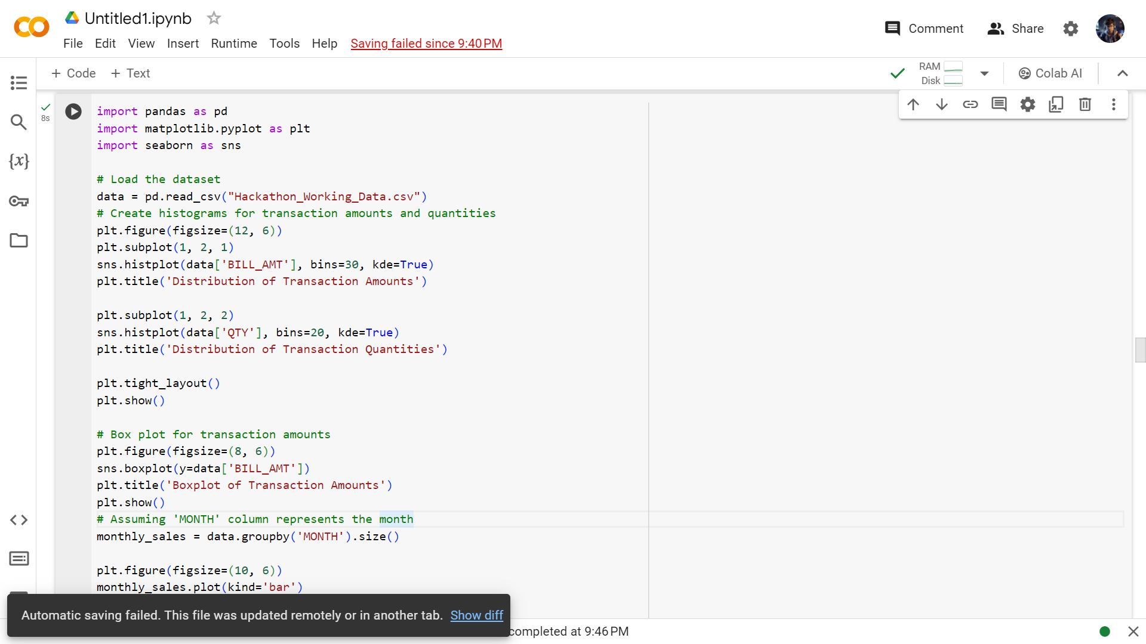**Predictive Modeling**

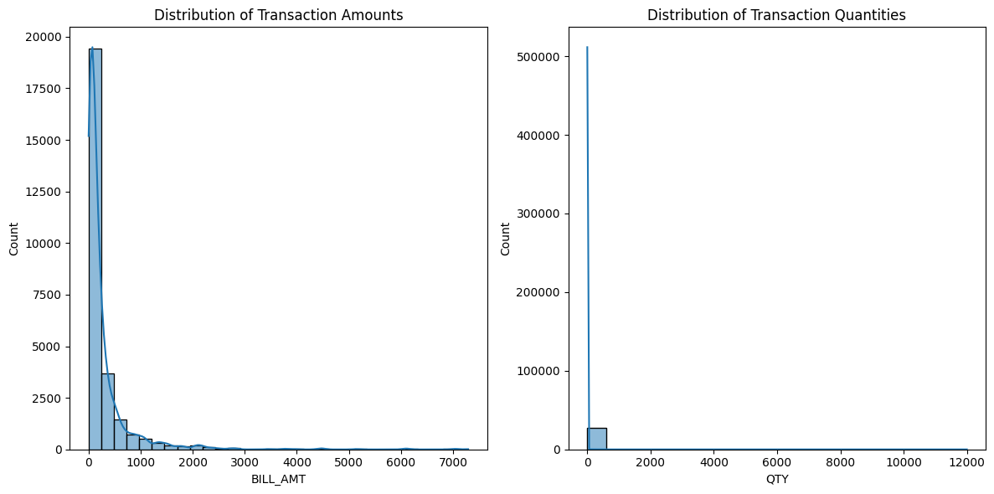O/P:

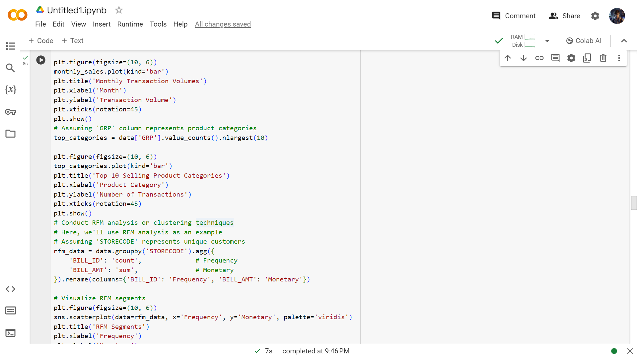

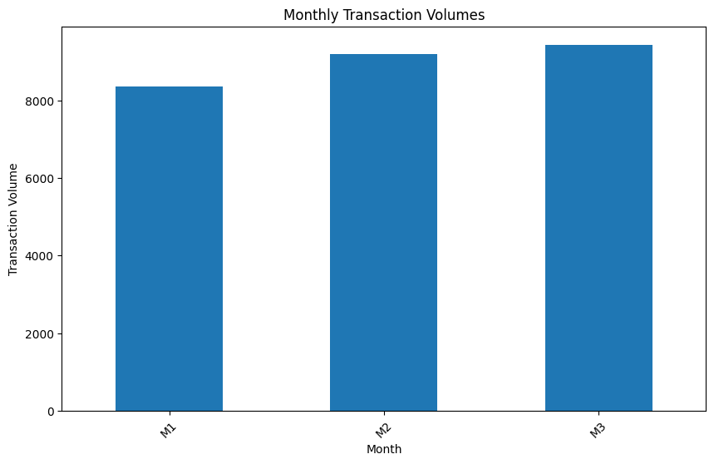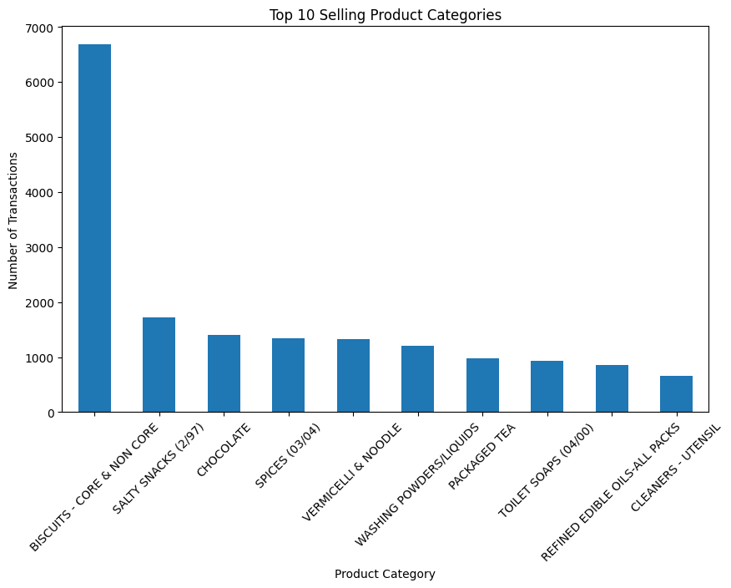

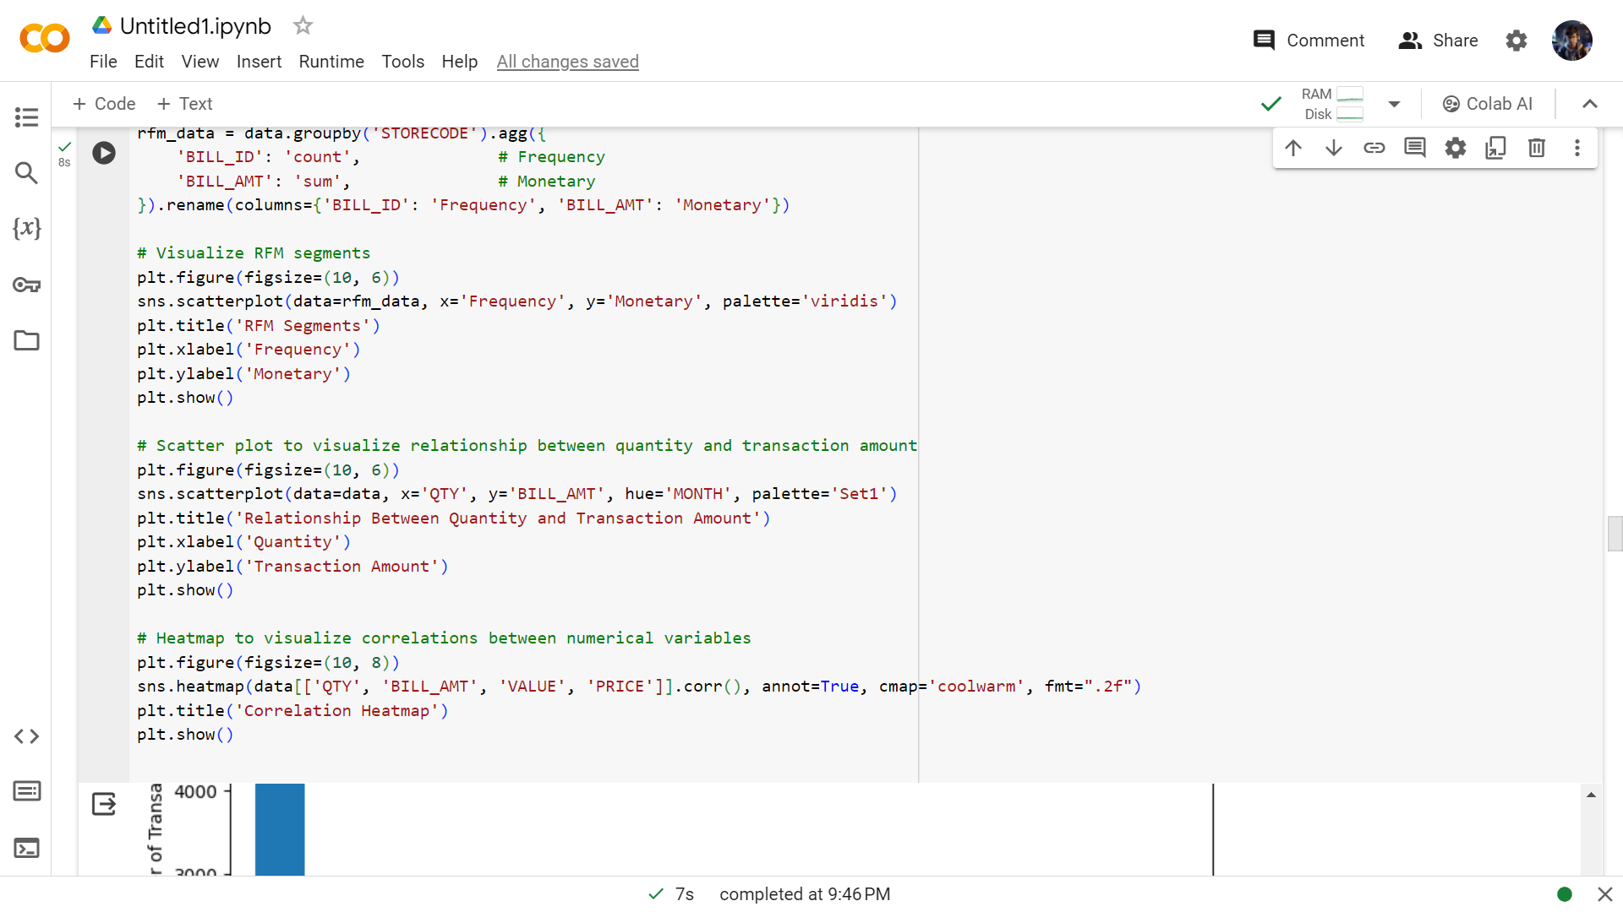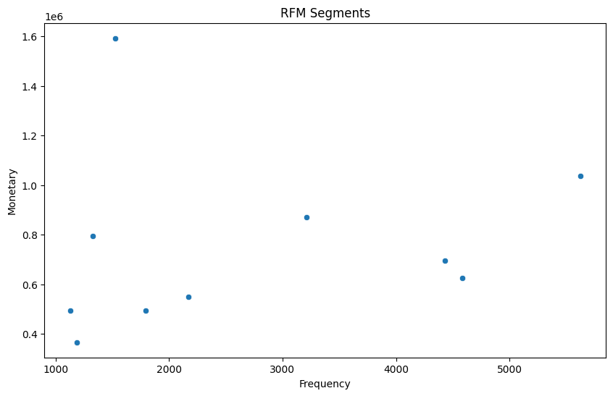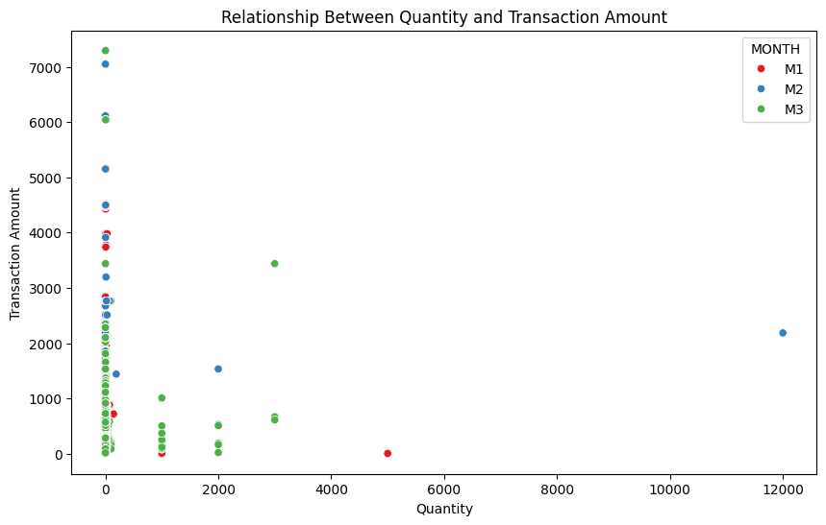**Customer Behavior Analysis:**

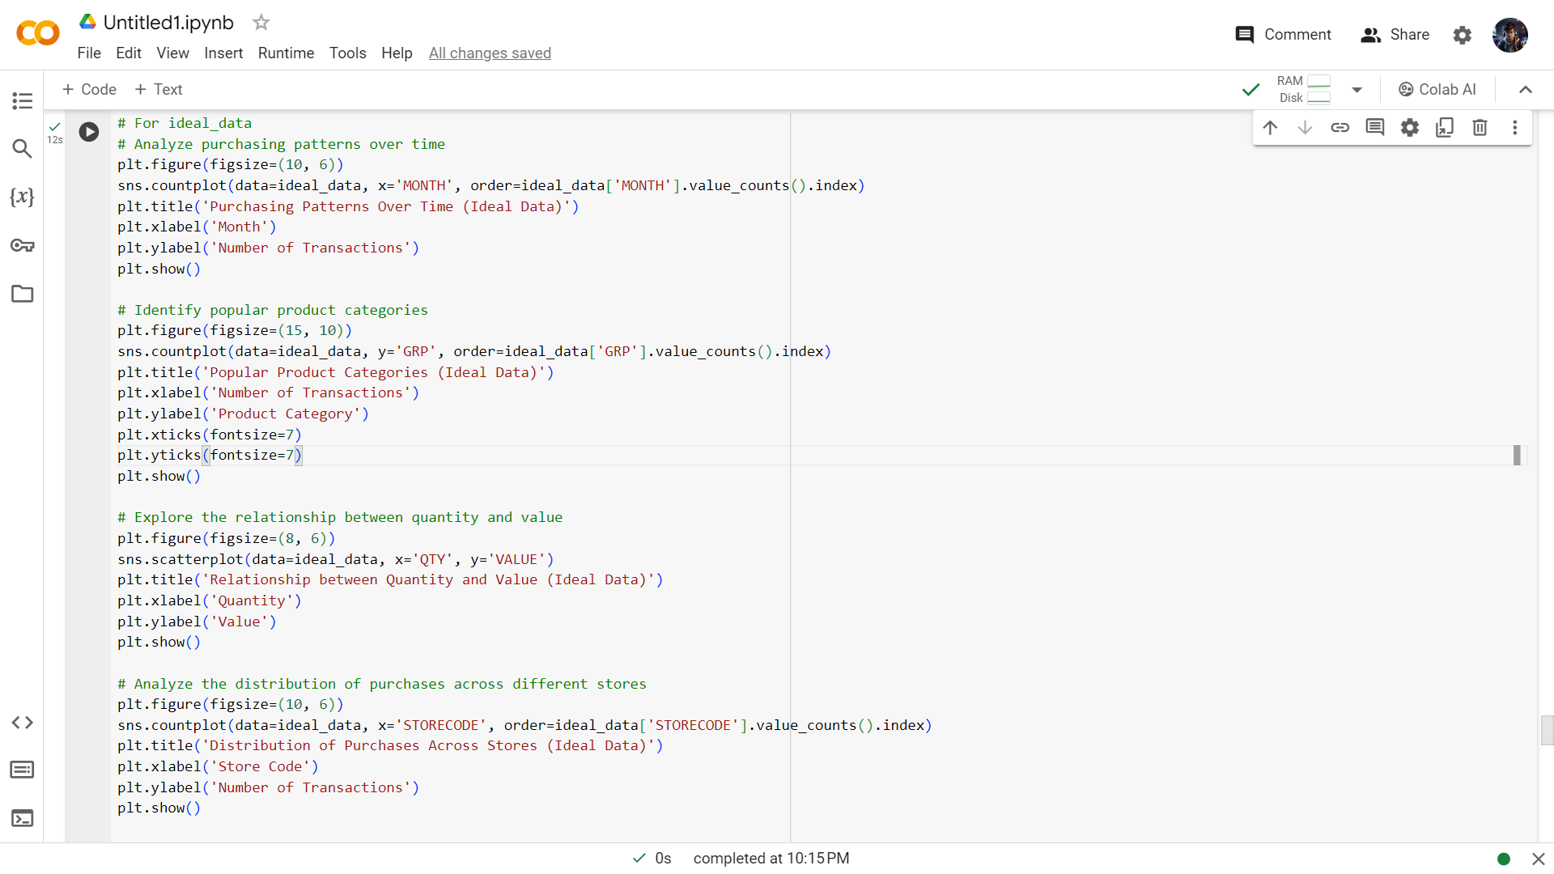**For ideal_data:**

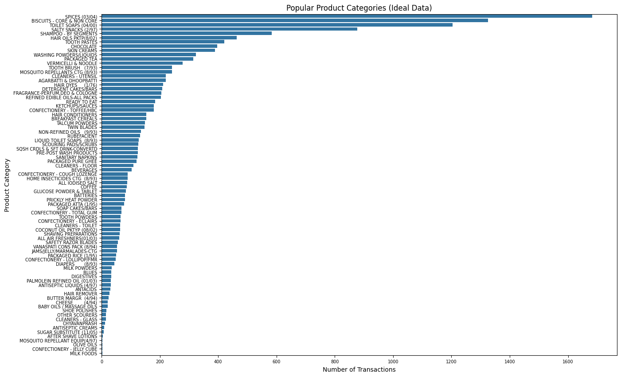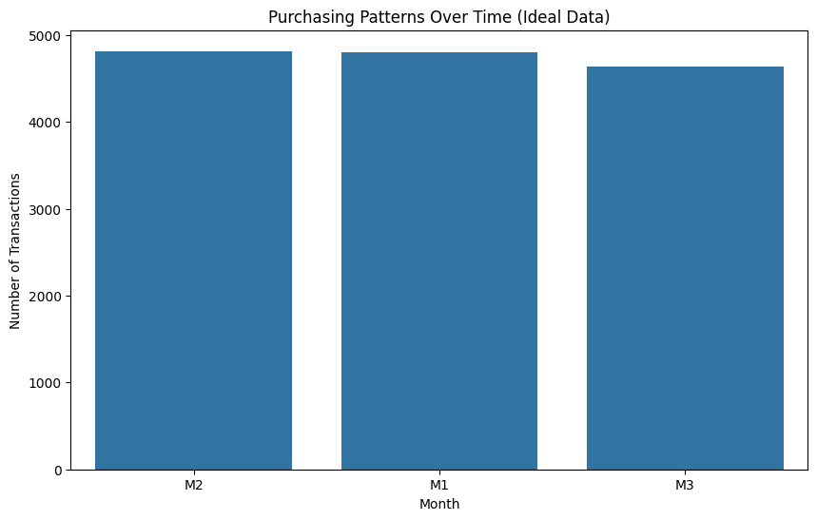

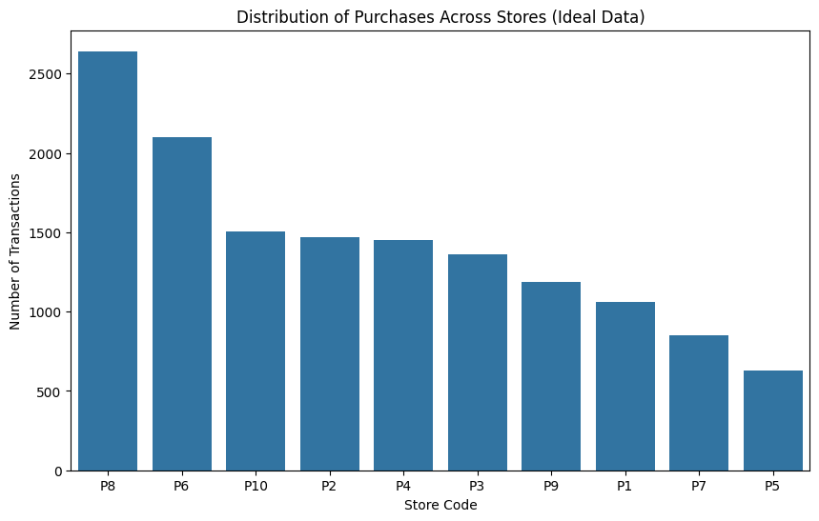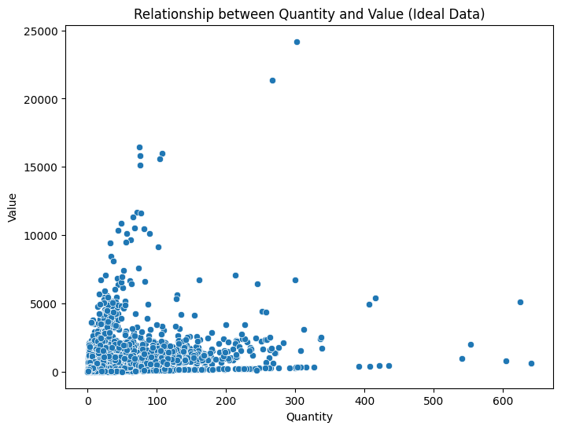

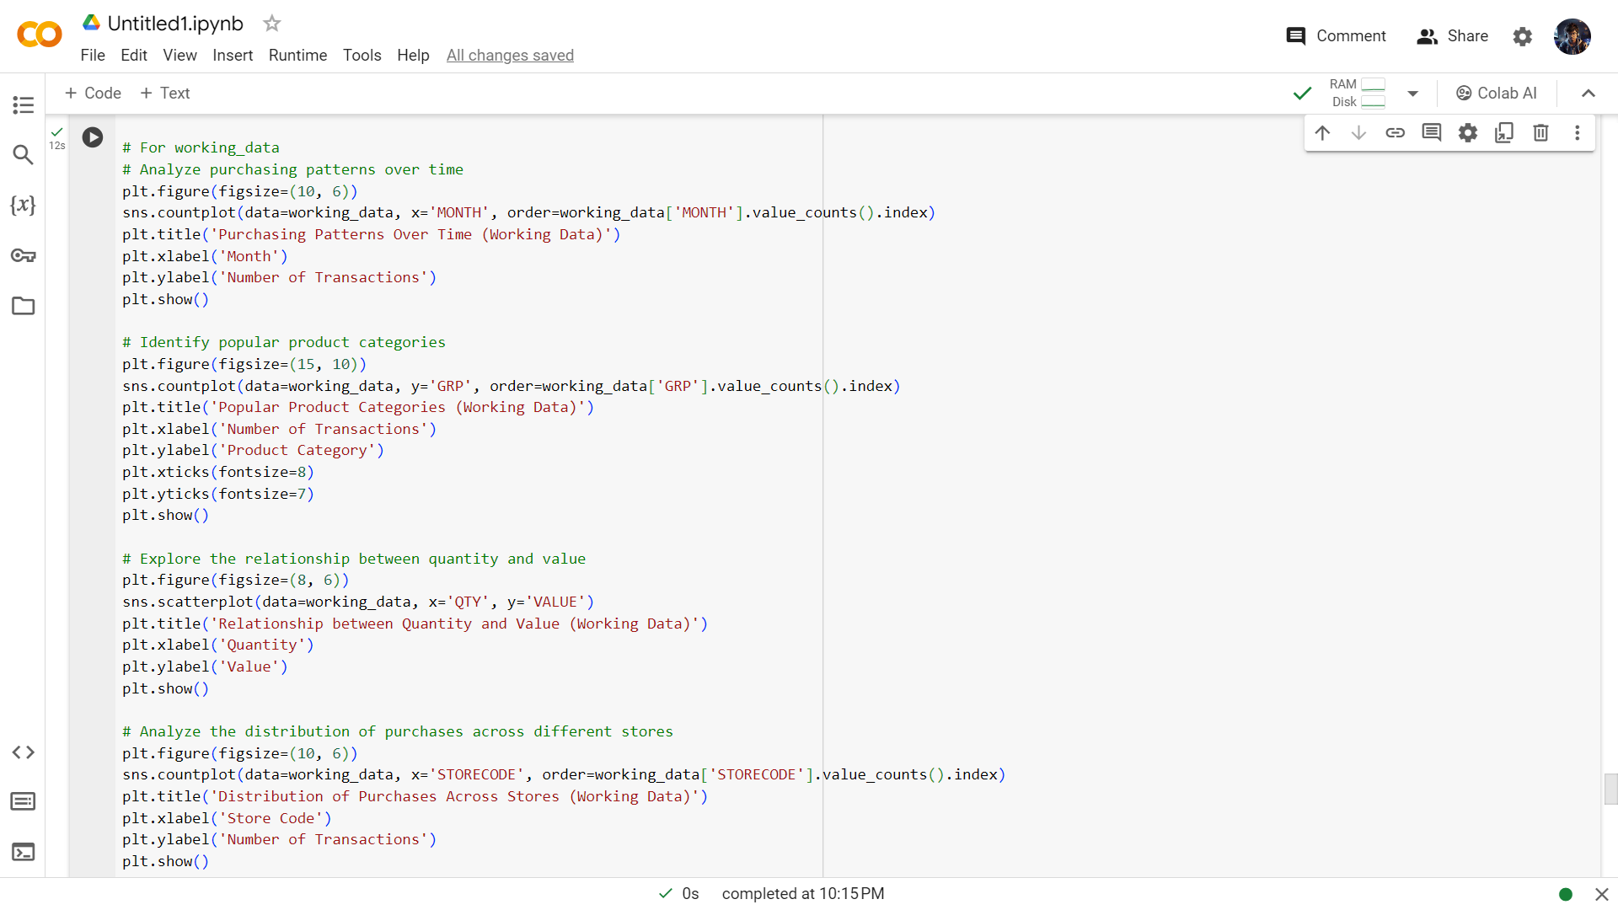**For Working_data**

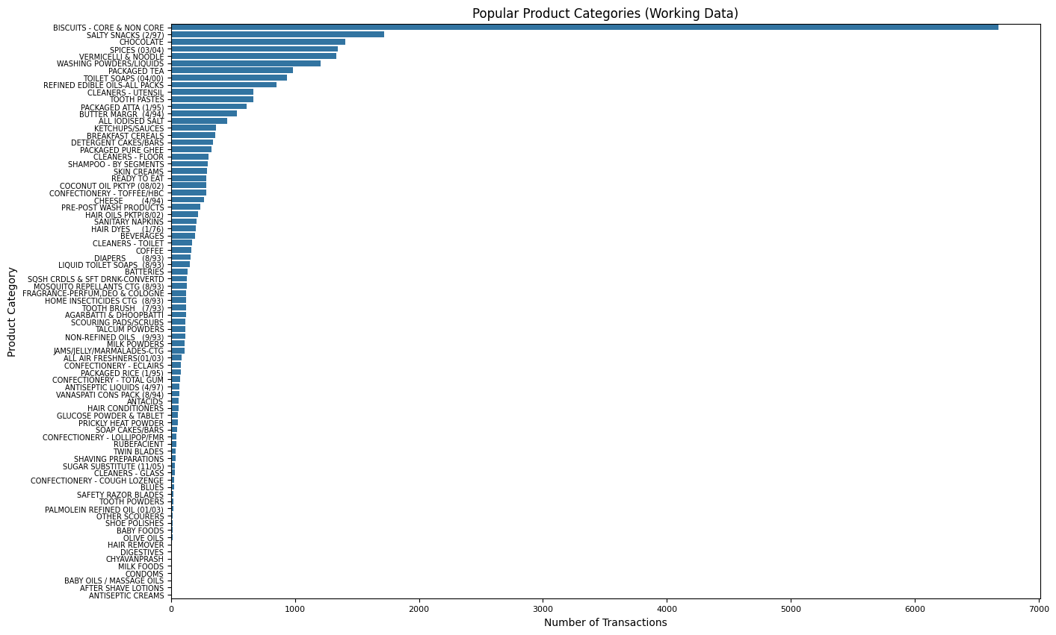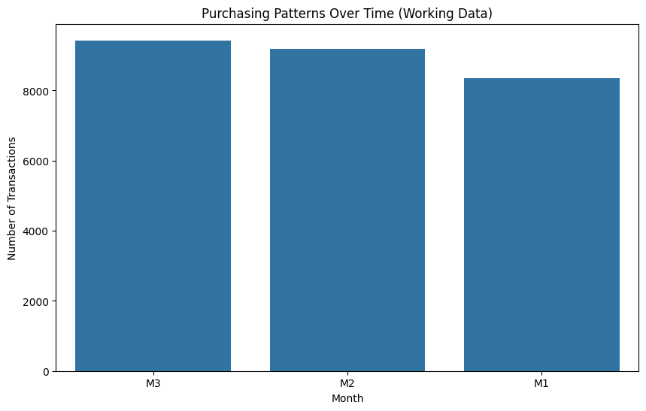

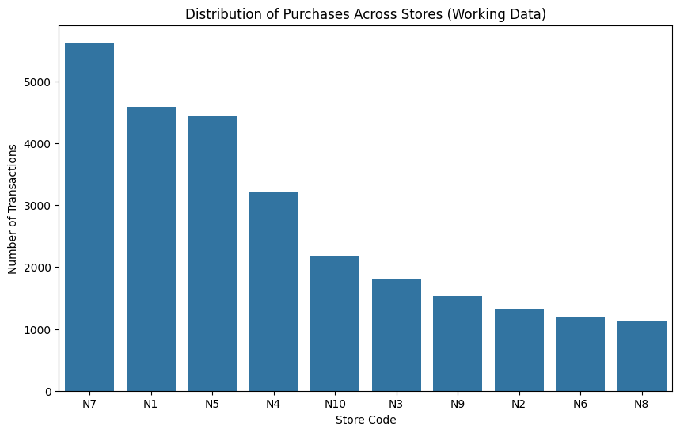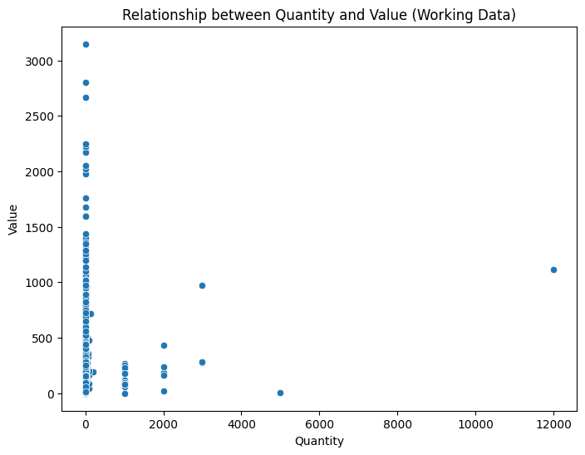

**Visualization and Reporting:**

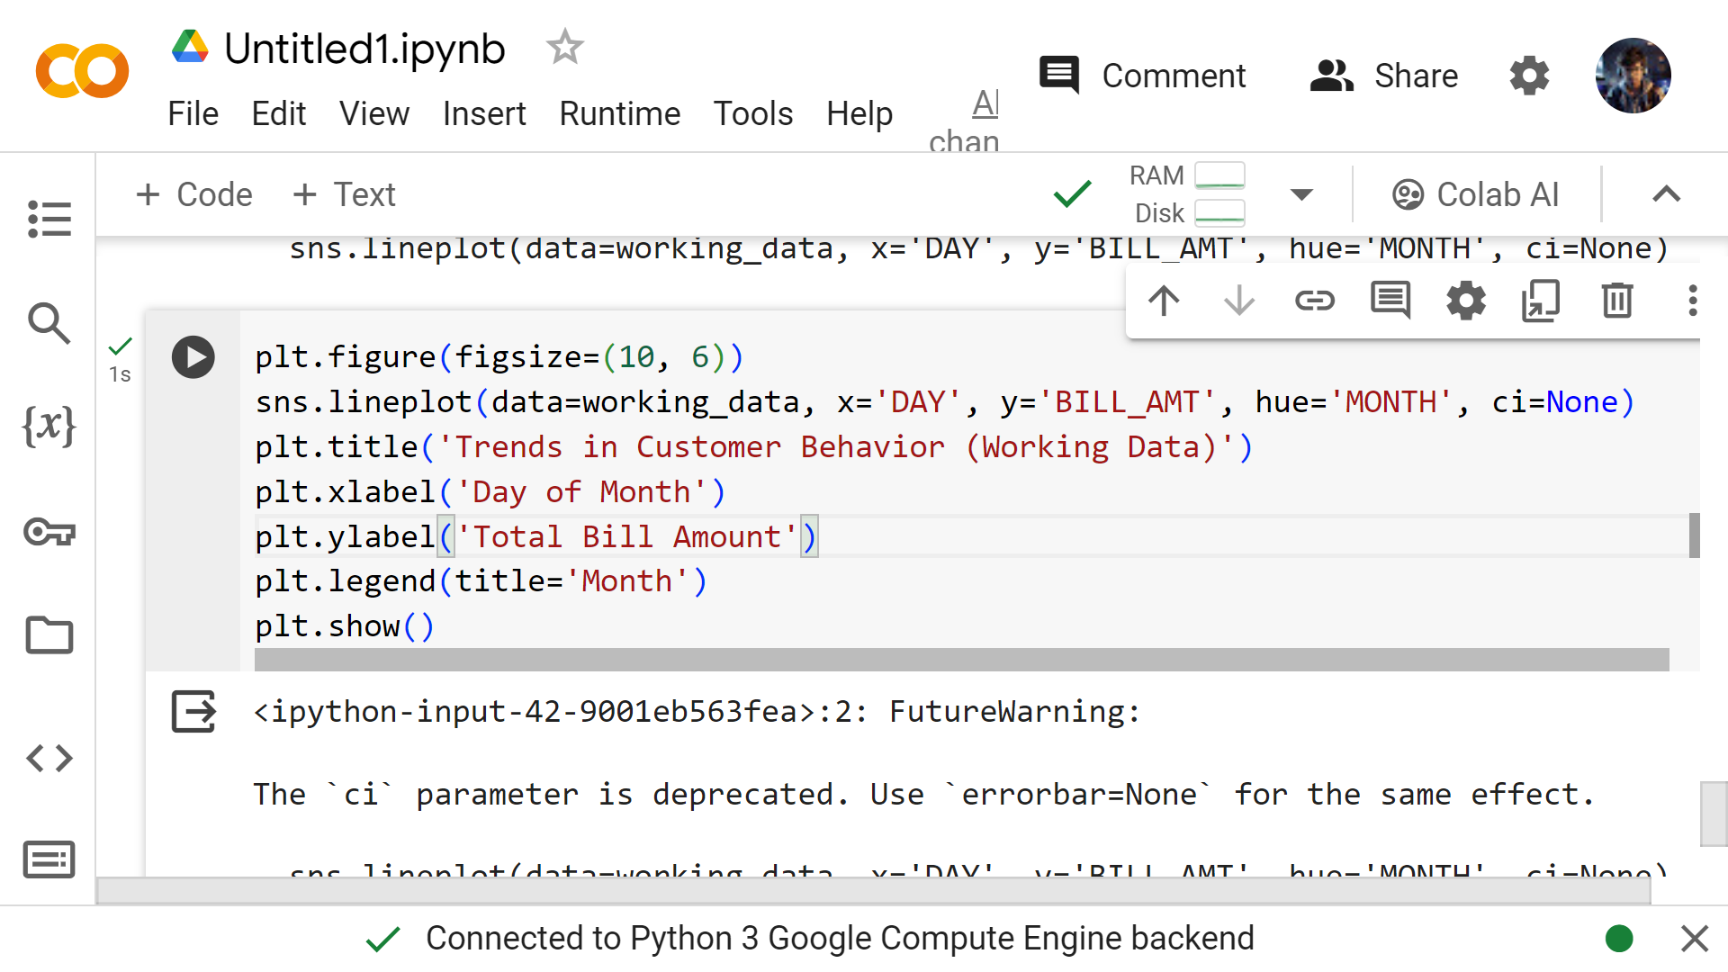

**Customer Behavior:**

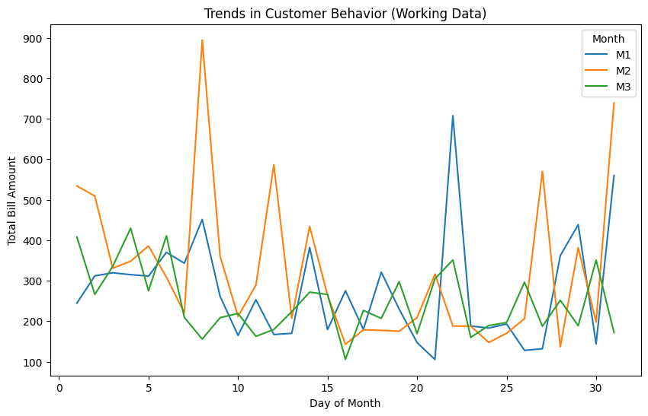

**conclusion** **:**

In conclusion, the analysis of customer behavior based on transactional data has provided valuable insights into various aspects of customer preferences, purchasing patterns, and overall behavior. Through exploratory data analysis (EDA), we have uncovered key trends, such as the distribution of sales across different stores, brands, and categories, as well as fluctuations in sales over time. By segmenting customers based on their purchasing behavior, we have identified distinct customer groups and their unique preferences.

Moreover, predictive modeling has allowed us to forecast total sales accurately, enabling better decision-making for inventory management and marketing strategies. These insights can be leveraged to tailor marketing campaigns, optimize product offerings, and enhance customer experience, ultimately driving business growth and profitability.

Moving forward, continuous monitoring of customer behavior and refinement of analytical techniques will be crucial for staying responsive to evolving market dynamics and customer needs. By adopting a data-driven approach, businesses can adapt proactively to changes in consumer behavior and maintain a competitive edge in the market.